**Computer Network Lab**



**Lab Task 13**

**Submitted by**

**Name:** Fatima Tul Zahra

**Roll No:** Bsdsm-f22-017

**Section:** 5A

**Program:** Data Science

**Submitted To**

**Sir** Rasikh

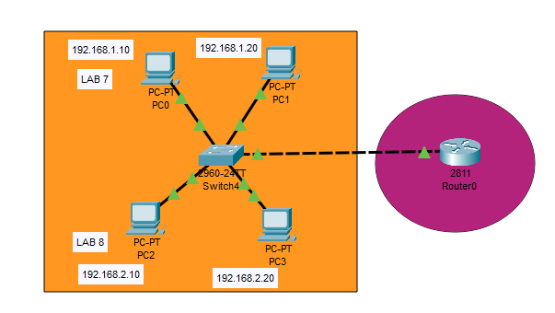

**Commands:**

